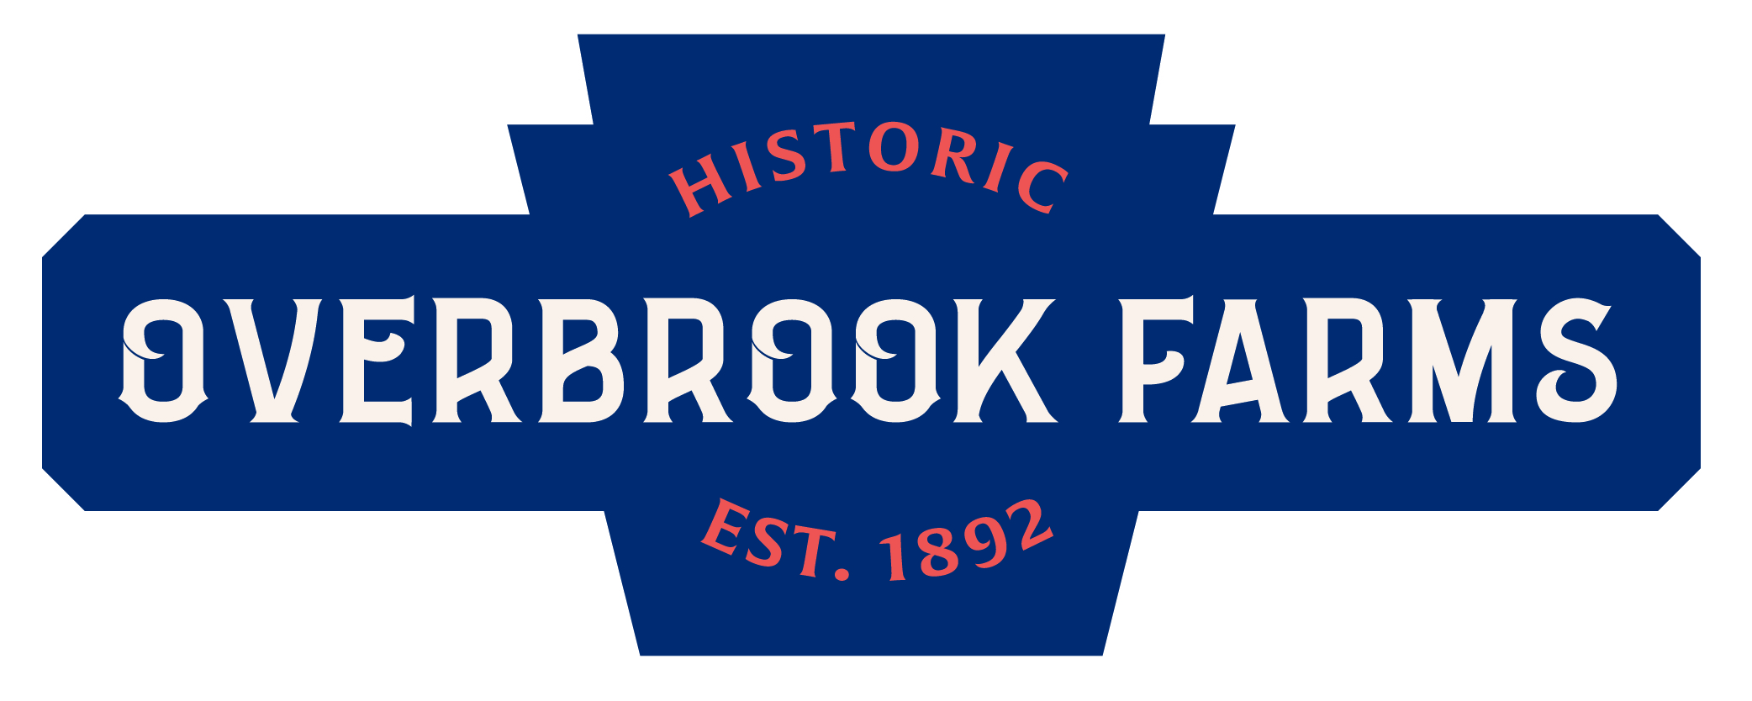

Overbrook Farms Club | Board of Directors

Meeting 1 - CY2020 Cycle

Date: January 16, 2020
Location: Overbrook Presbyterian Church, Chapel
Time: 7:00 - 8:30pm
Contact: Thaddeus Squire | 215 760 1634 | ofcexecutivecommittee@gmail.com

AGENDA

- Call to Order

- Consent Agenda
  - Approval of Minutes for November 21, 2019
  - Approval of Agenda for January 16, 2020

- Discussion Agenda
  - Treasurer’s Report
  - Update on IRS Exemption & Merchant Account
  - Update on CBA with Rock Development & SJU
  - Zoning Request for Lancaster Ave Property
  - Speed Cushions & Streets Matters
  - Next Steps on Website and Membership/Program Responses to Survey
  - Spring Event - Participant Survey

- Adjourn

